Lab assignment 9.1

Name: T.Mahesh

H.no: 2403A51371

Batch -14

ask Description #1 (Documentation – Google-Style Docstrings for  
Python Functions)  
• Task: Use AI to add Google-style docstrings to all functions in a  
given Python script.

**code**

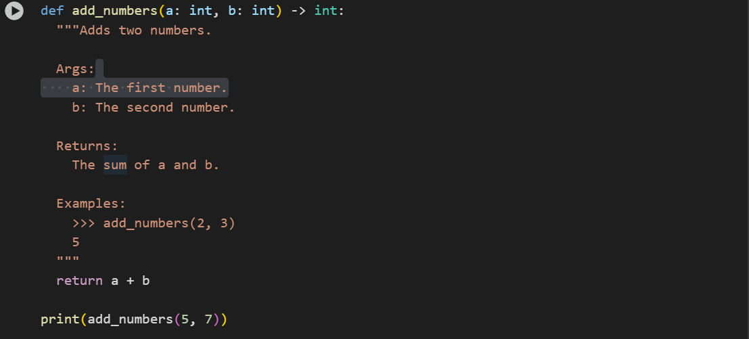

Task Description #2 (Documentation – Inline Comments for Complex  
Logic)  
• Task: Use AI to add meaningful inline comments to a Python  
program explaining only complex logic parts.  
• Instructions:

**CODE**

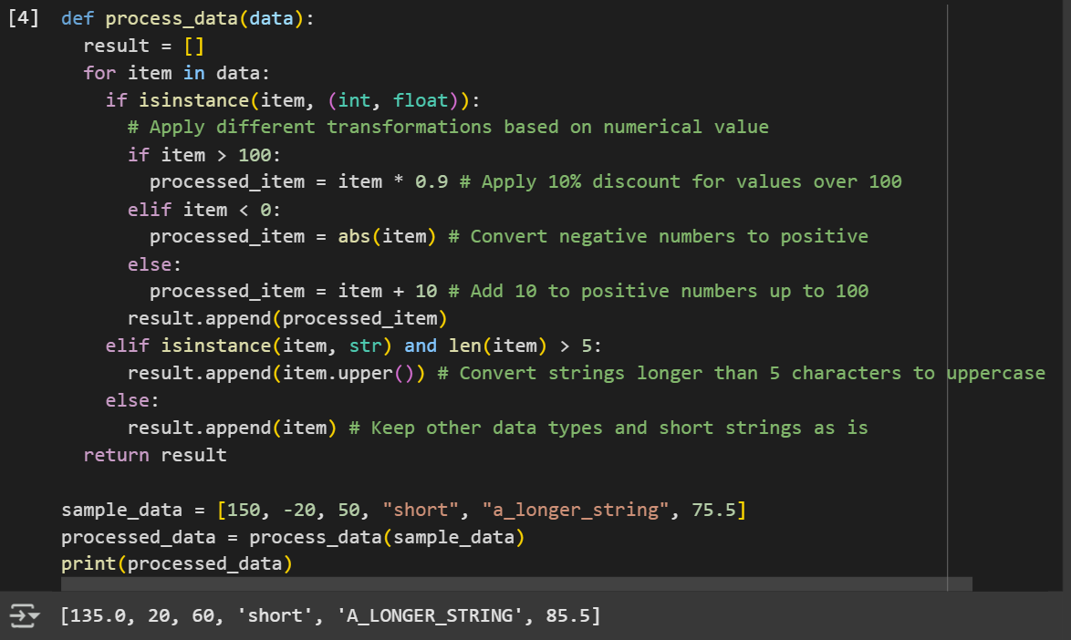

Task Description #3 (Documentation – Module-Level Documentation)  
• Task: Use AI to create a module-level docstring summarizing the  
purpose, dependencies, and main functions/classes of a Python  
file.

**CODE**

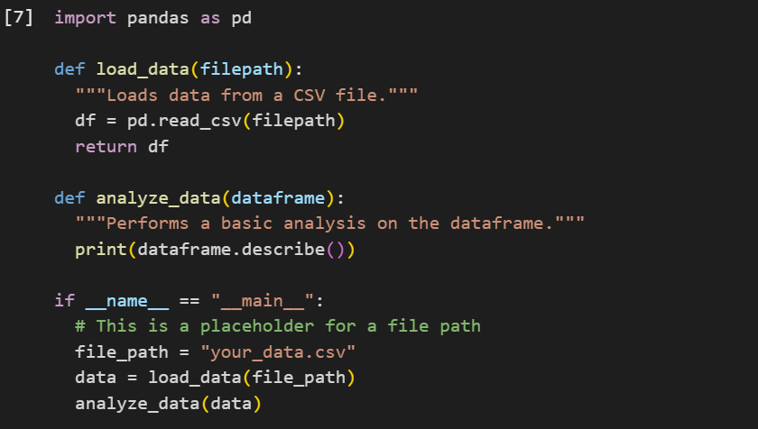

Ask Description #4 (Documentation – Convert Comments to  
Structured Docstrings)  
• Task: Use AI to transform existing inline comments into  
structured function docstrings following Google style

**CODE**

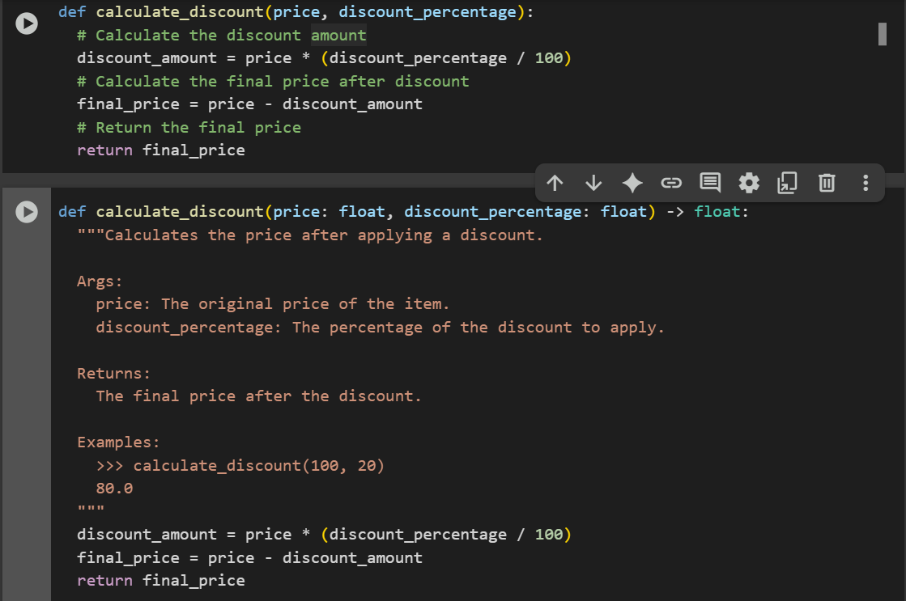

Ask Description #5 (Documentation – Review and Correct  
Docstrings)  
• Task: Use AI to identify and correct inaccuracies in existing  
docstrings

**CODE**

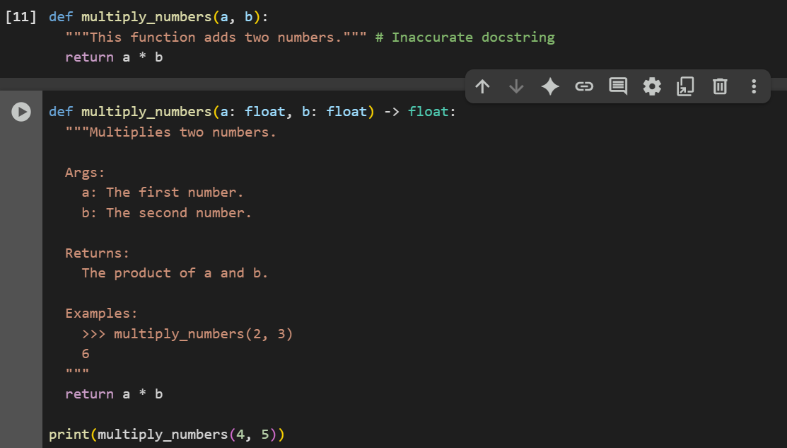

Task Description #6 (Documentation – Prompt Comparison  
Experiment)

• Task: Compare documentation output from a vague prompt and a  
detailed prompt for the same Python function.

**CODE**

